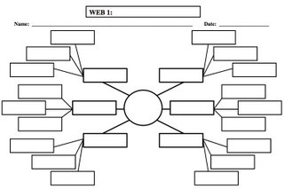

Is underage drinking a bigger problem in college?

Do you think the drinking age should be lowered to 18 or stay at 21?

Do you think legalizing some drugs will help prevent abuse of them?

Are there any personal examples you have with substance abuse?

Why do you think younger ages abuse substances?

Do you think substance abuse is a big problem?

**AFTER** the discussion, answer these questions:

* + **How did I positively contribute to the group (list 2 specific instances)?**
  + **How can I improve my future involvement in our group discussions?**